12/18/2025
Nhat Ha Pham

Process and Safety Group Assignment
SCARA Robot

Table of Contents
Process 2
Functionally analyzed process of the project 2
Interaction between Parts/Modules 2
Visualization Quality 3
Main Function Flowchart 3
Sub Function Flowchart 3
Discussion with Clients 3
Safety 3
Definition of Performance Level 3
Risk Assessment 3
Self-Evaluation 3
Group Works 3
Future Improvement 4

Process

Functionally analyzed process of the project
To analyze the functionality and the process of the project, a node tree diagram was made.
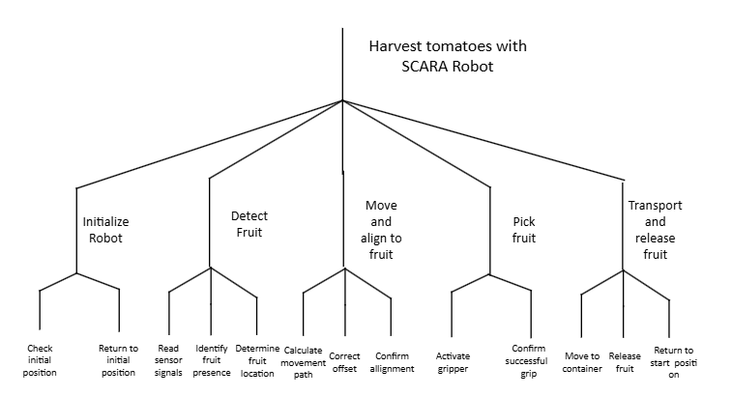
Figure 1, Node tree diagram about functionality of the project.

Interaction between Parts/Modules
The figure below illustrates how the hardware components connected and communicated to the other.
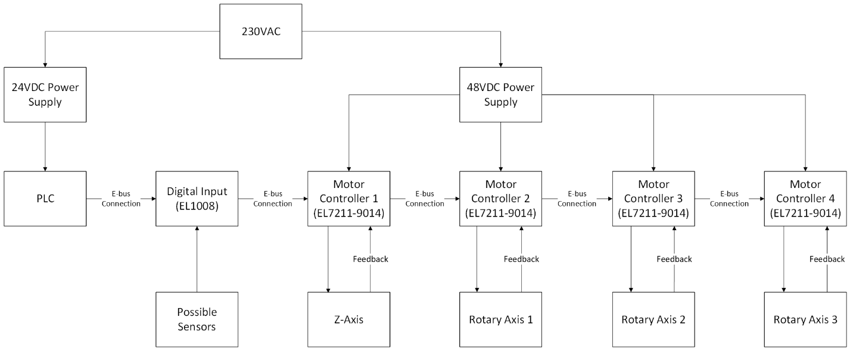
Figure 2, Diagram shows how the hardware parts connected to each other.

Visualization Quality

Main Function Flowchart
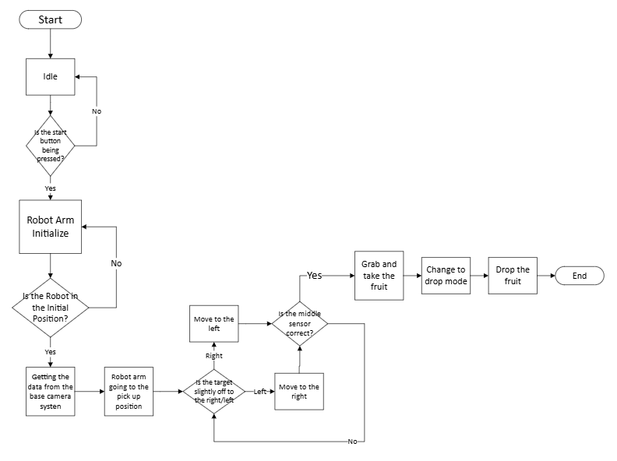
Figure 3, Main Function flowchart of the Project.

Sub Function Flowchart
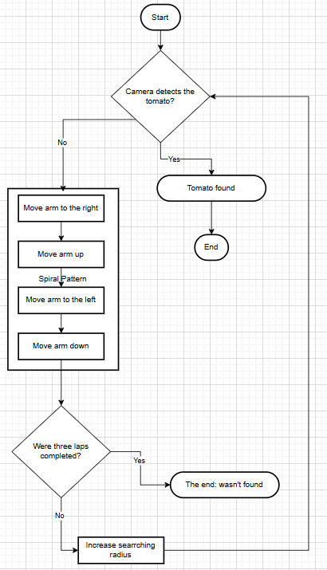

Discussion with Clients
A poster included the progress of the project, and the future plans of the project was made to discuss with the customer.
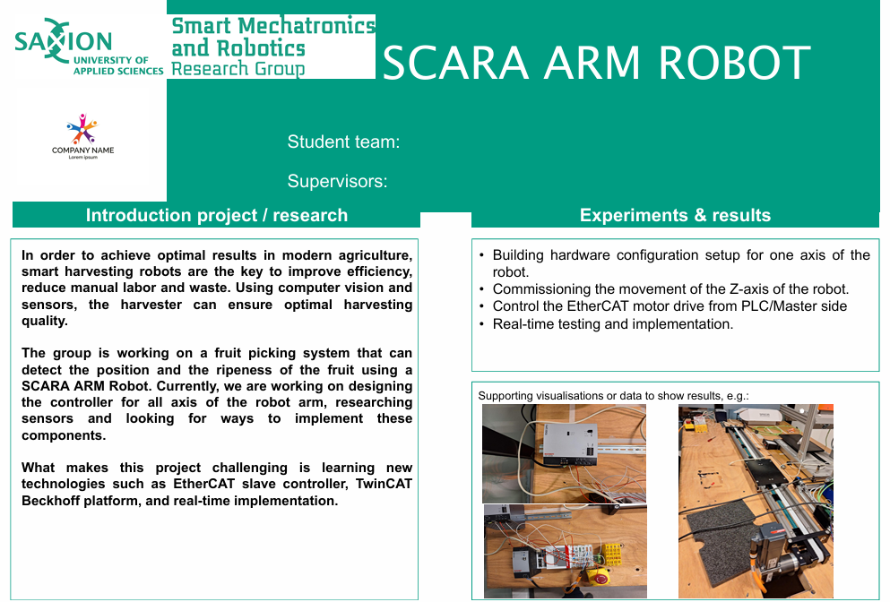
Figure 4, Poster to discuss with the clients.
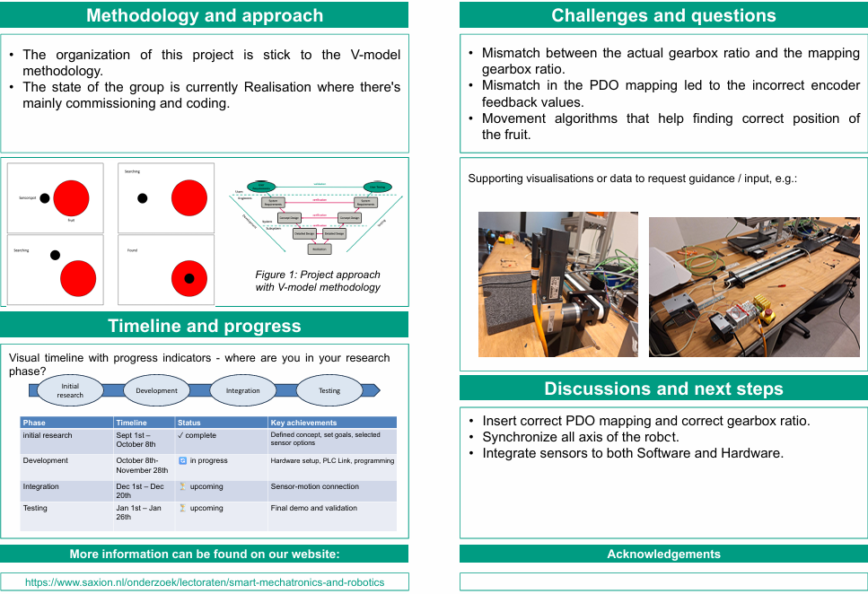
Figure 5, Poster to discuss with the clients

Safety

Risk Assessment
This risk assessment applies to student that are working on the setup. It is made using the ISO 12100 Norm.
The history of the risk assessment can be found inside the git repository

Definition of Performance Level
Connecting with the Risk Assessment
In the previous chapter, our group saw that robots have some high risks. The risk assessment table shows that movement when starting up has a consequence of 5 and a probability of 3, giving it a total risk value of 15. The risk of getting hit by the robot is also a high value of 12.
Since a consequence of 5 means a very serious injury, we need to define a specific Performance Level to make sure the robot stops when it is supposed to.

Finding the required value
To find out exactly what level we need, our group translated the values from the risk assessment to the ISO 13849-1 standard parameters.
- Severity: S2 (Serious injury)
This parameter is selected because the Risk Assessment indicates a consequence of 5. The robot operates with high-torque motors at 48V, meaning an impact could cause permanent physical damage.
- Frequency: F1 (Seldom)
The probability of 3 indicates that exposure isn’t continuous. The system operates in a loop, so operator interaction occurs mainly during maintenance or setup.
- Possibility of avoidance: P2 (Hard to avoid)
The robotic arm moves rapidly during the move and align phase. Avoiding unexpected movements is very hard.
Based on the combination of S2, F1, P2, the standard requires a target of PL d.

Safety implementation
To achieve the required safety level, the control system is designed using the architecture shown in the wiring diagram.
Input: The emergency button is connected to the EL1008 Digital Input Terminal to transmit the stop signal.
Logic: The PLC processes the signal. When activated, the control program triggers the stop sequence.
Output: The PLC commands the four motor controllers to cut power to the motors.
Diagnostics: To detect faults, the system utilizes the feedback, this allows the PLC to verify if the motors have stopped. If the controller stops but the feedback indicates movement, the system detects the error.

Self-Evaluation

Group Works
- The team members need to be more active.
- The tasks can be clearer and more equal.
- Stop playing games during working hours.

Future Improvement

